Date:

# EXPERIMENT NO. 3

#### AIM: Implement a 4-bit common bus system to interface four 4-bit registers with a common bus using i. Multiplexer and ii. Decoder and tristate buffers.

**CIRCUITS:**

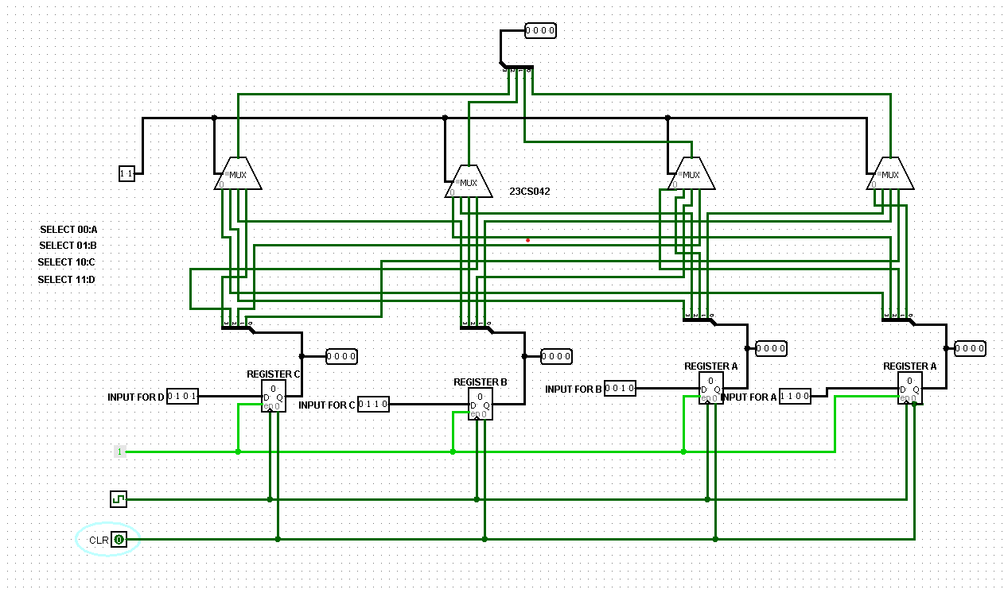

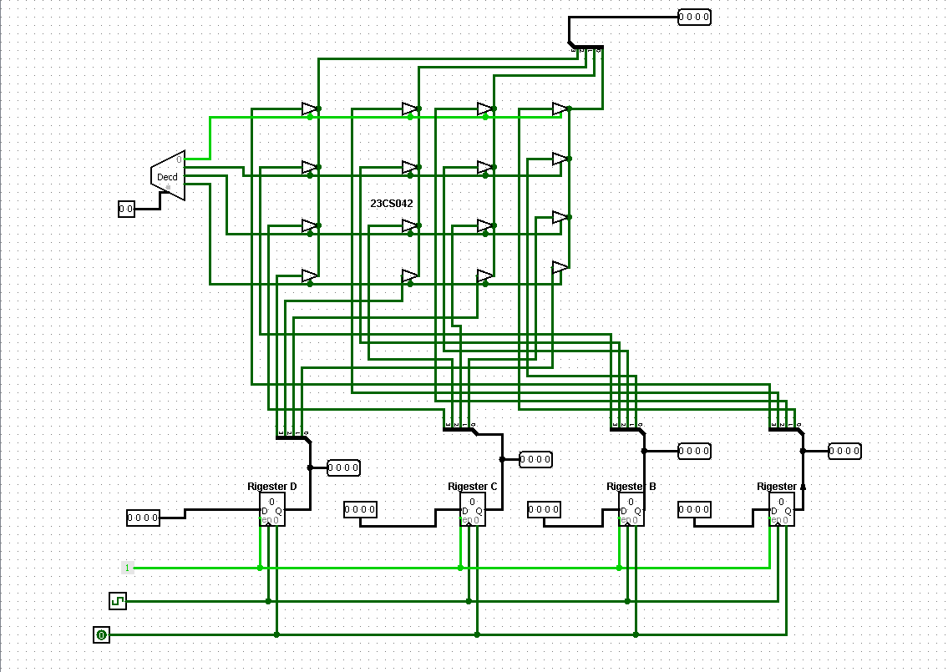

**OUTPUTS:**

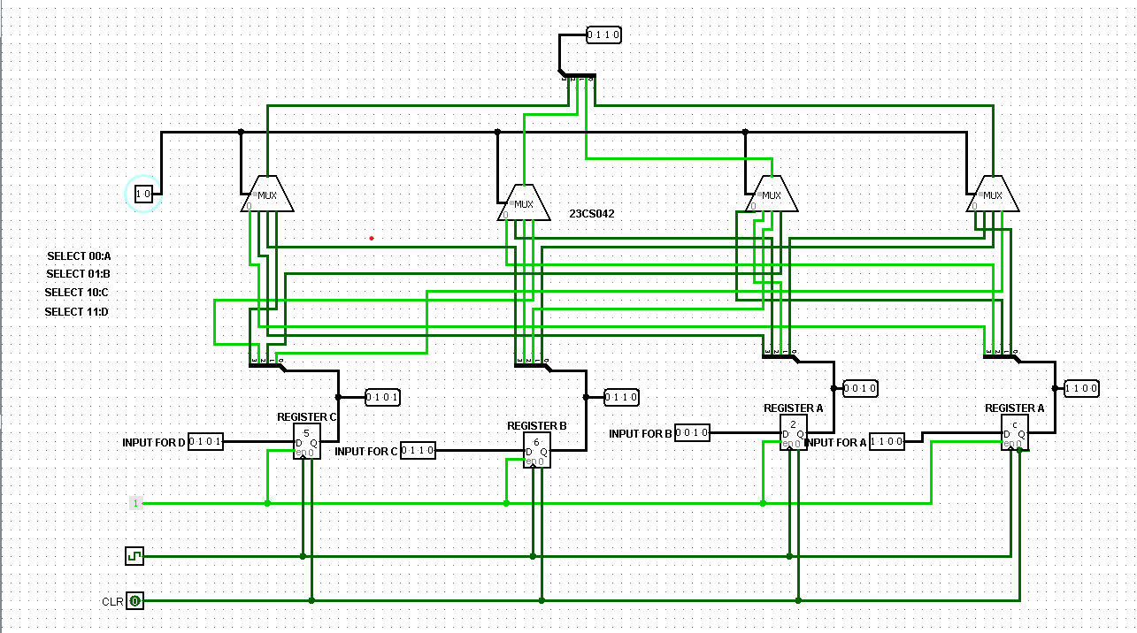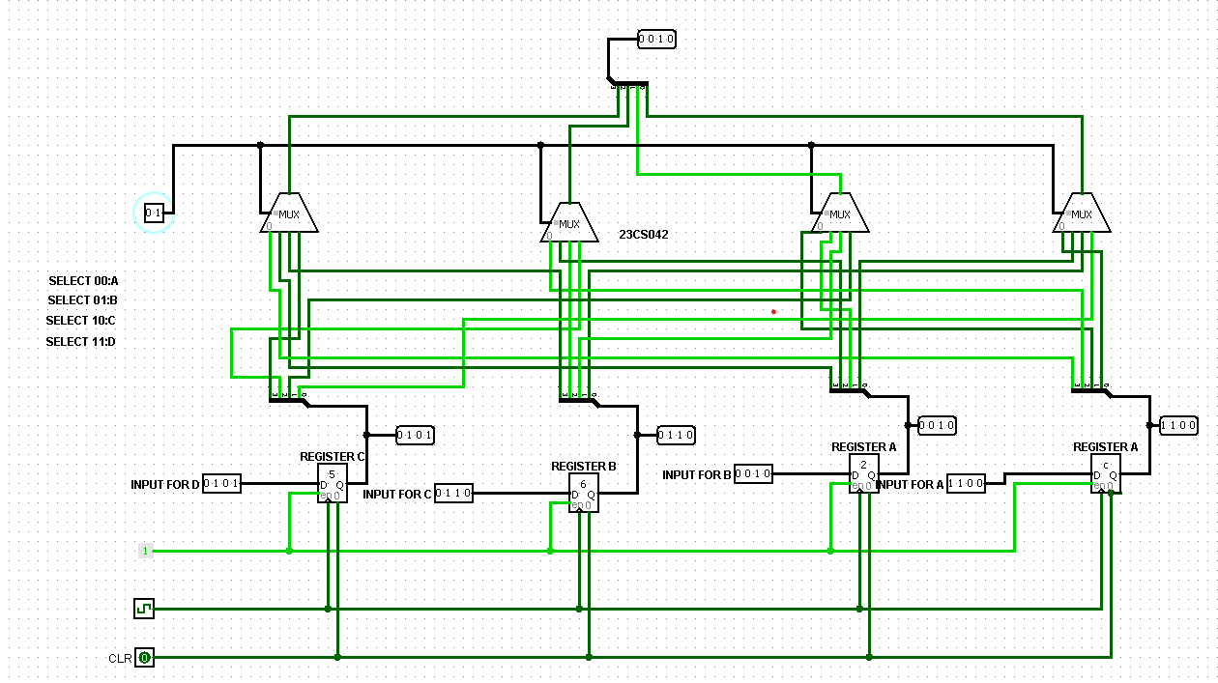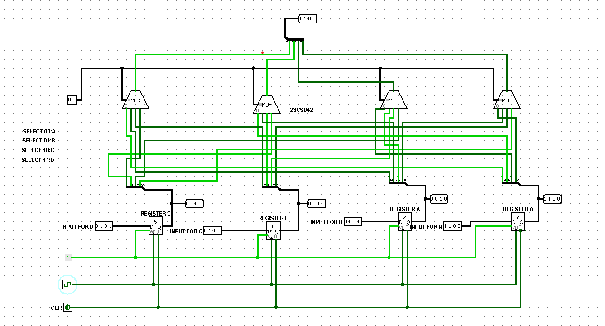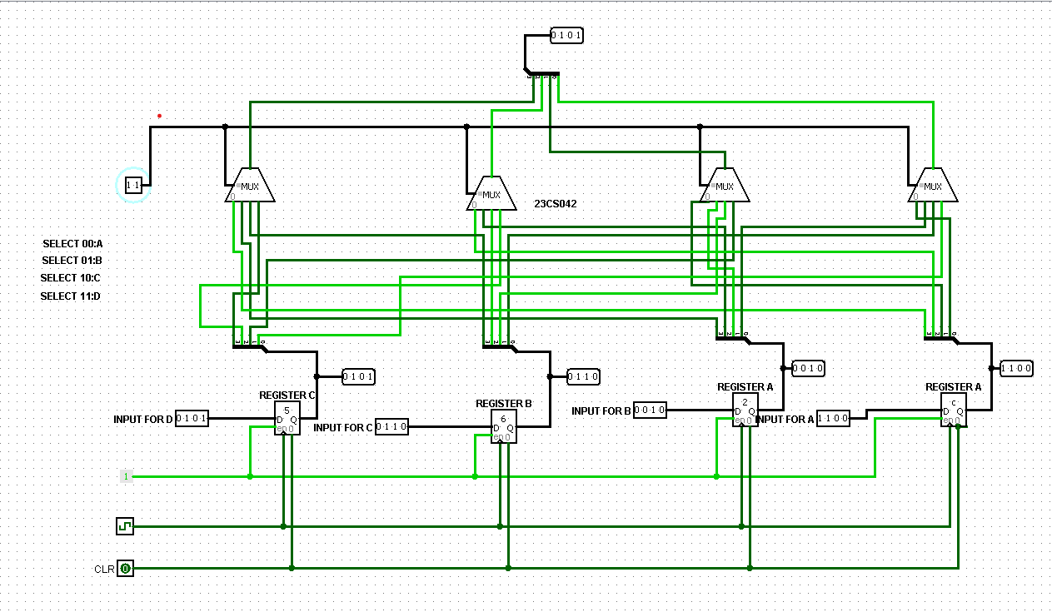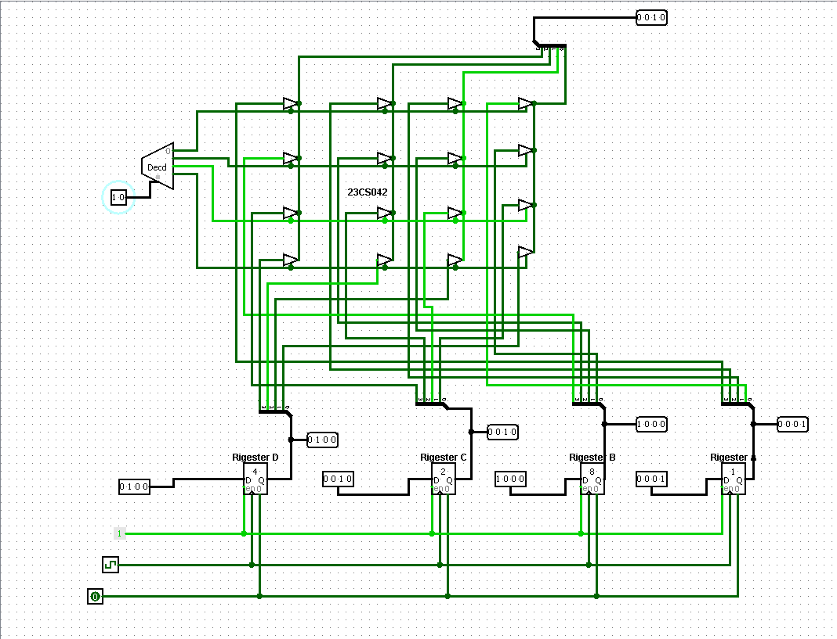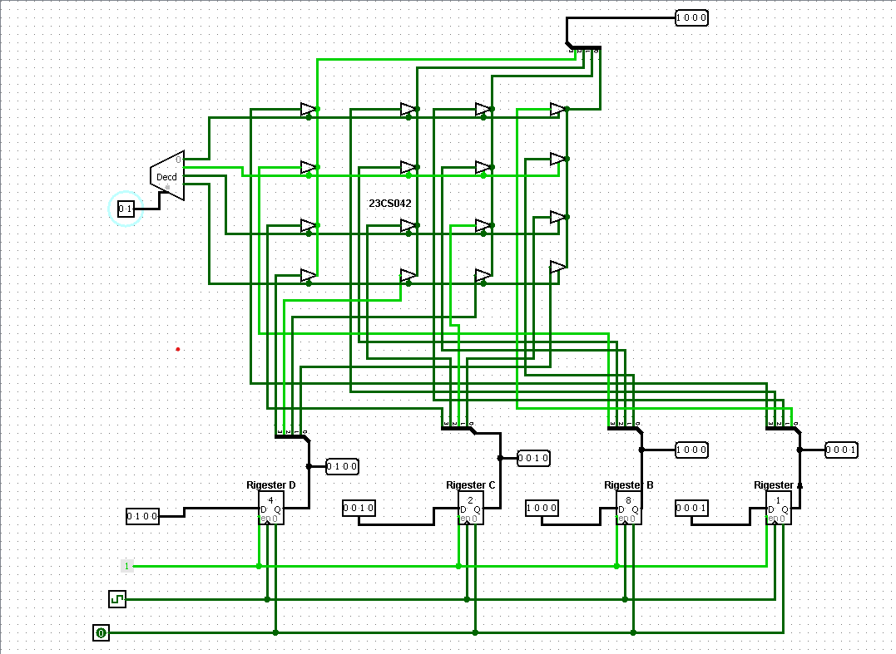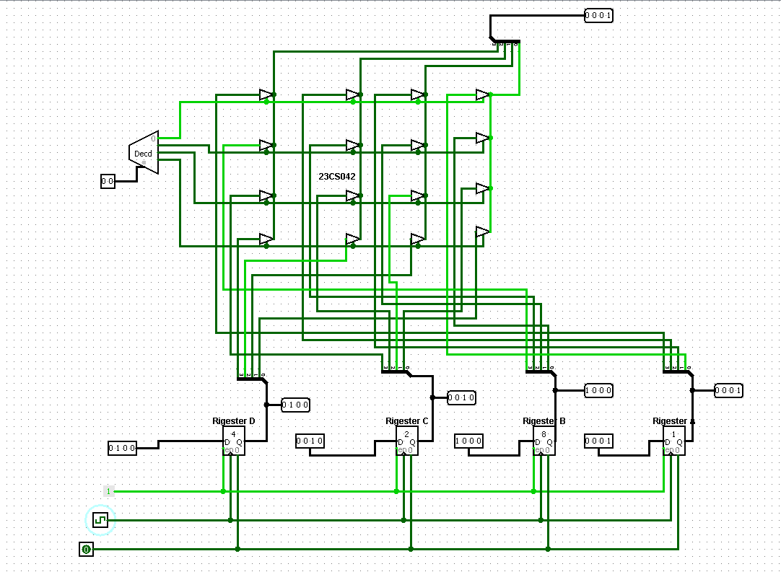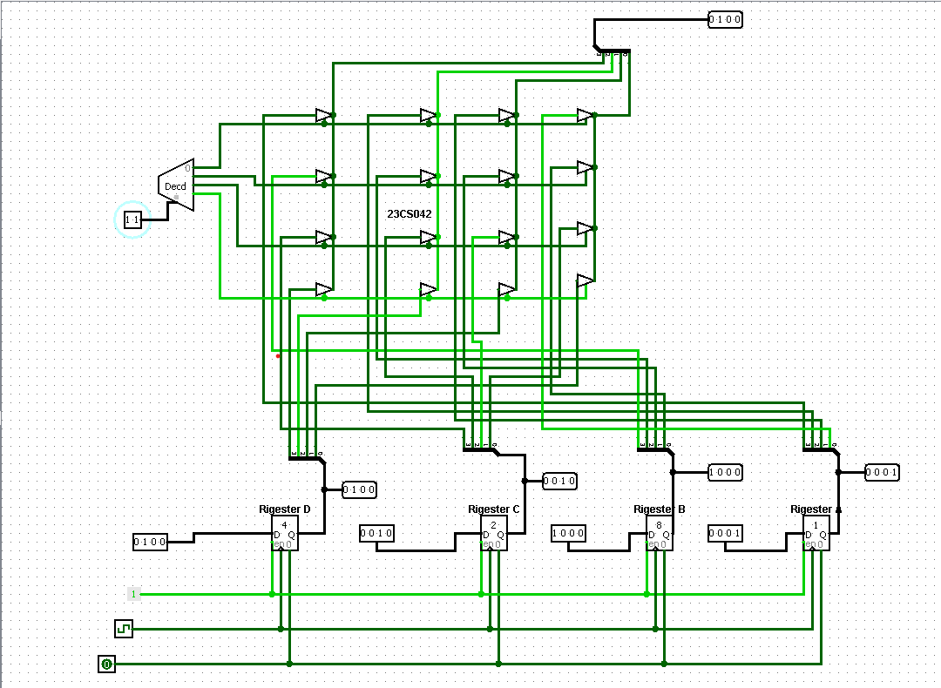

**CONCLUSION:**

**POST SESSION EXCERCISES:**

1. Find a number M=(MOD(Last Three Digits of your enrolment number, 5)+3) and find a number N=(MOD(Last Three Digits of your enrolment number, 3)+3). Implement a M-bit common bus system to interface N M-bit registers with a common bus using i. Multiplexer and ii. Decoder and tristate buffers.

M=(42%5)+3

M=(2+3)=5

N=(42%3)+3

N=(0+3)=3

#### AIM: Implement a 5-bit common bus system to interface three 5-bit registers with a common bus using i. Multiplexer and ii. Decoder and tristate buffers.

**CIRCUITS:**

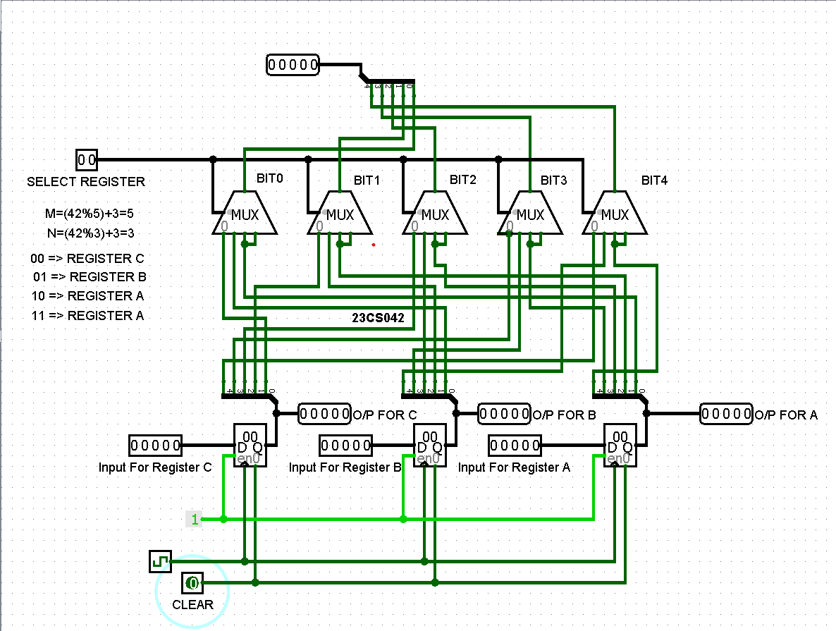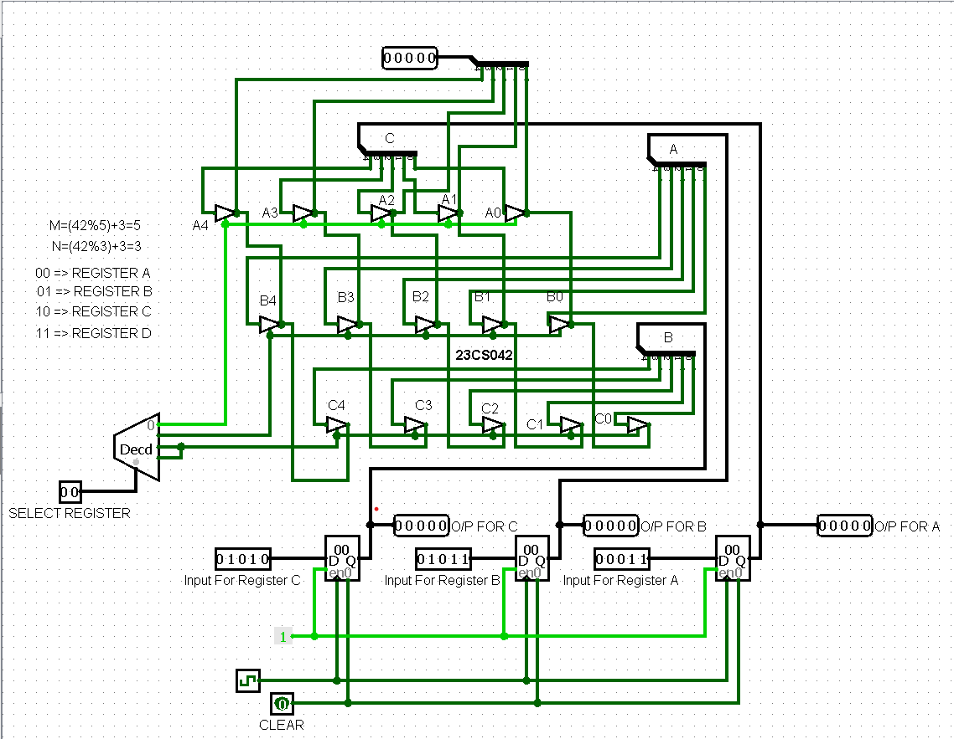

**OUTPUTS:**

